**AFRL Research Collaboration Program**

**Contract FA8650-13-C-5800**

**Effect of Constituents and Microstructure on Energy Dissipation Mechanisms During Damage Growth**

**University: Texas A&M University**

**REPORT COVERS PERIOD: 10-1-17 THRU 12-30-17**

1. **PROJECT TEAM MEMBERS**
2. **LEAD UNIVERSITY POC:** John Whitcomb, 979-845-4006, jdw@tamu.edu
3. **PROJECT TEAM MEMBERS:** John Whitcomb, Collin Blake
4. **AFRL TECHNICAL POC:** Craig Przybyla
5. **TECHNICAL DISCUSSION**
6. **CURRENT WORK**Development of the infrastructure to perform mesoscale analysis of 3D textile composites.

**Background**

In the past couple of years, another graduate student, Scott McQuien, explored the accuracy of the VTMS suite of tools in predicting stresses in plain weave composites. Although Scott discovered a number of issues with the software, the geometry modeling capabilities were quite promising. Early in the last quarter, Keith Ballard, developed techniques to use the geometry calculated using VTMS and other modeling tools to develop a standard finite element model for a 3D textile composite. Based on Scott’s and Keith’s experience, we decided there was excellent potential for developing finite element models using the geometry engine. However, difficulties that Scott and Keith experienced convinced us that we needed to take a fresh look at the geometry creation component of VTMS and the subsequent finite element mesh generation. This past quarter, Collin began pursuing a NURBS solution to the penetration problem. The following describes Collin’s activities during the quarter. I should point out that Keith Ballard is not supported by this contract, but does provide mentoring for Keith.

**Approach**

* Show Generic results of VTMS again: Figure 1.

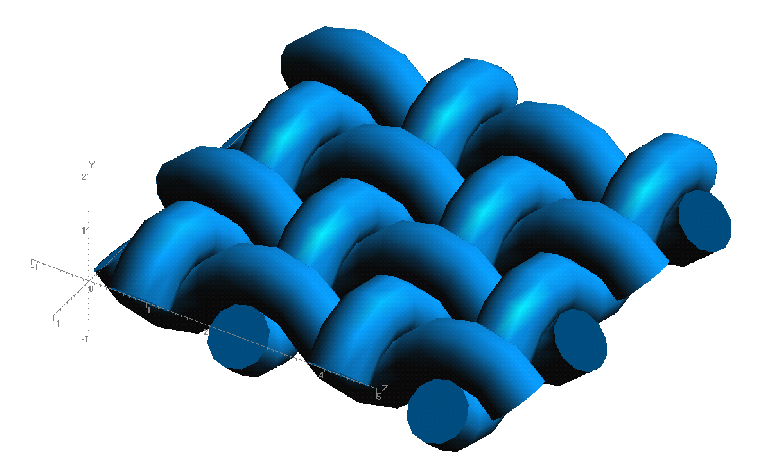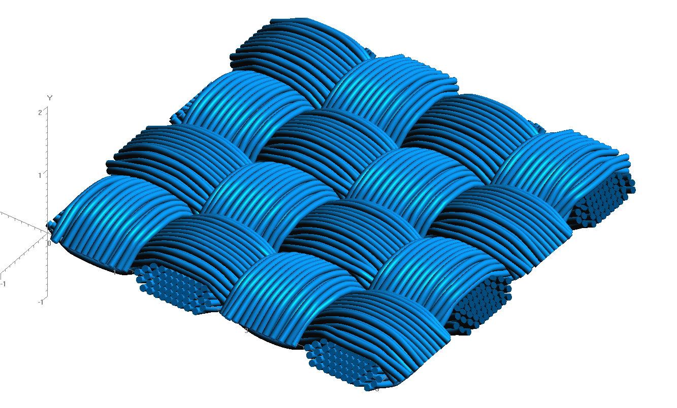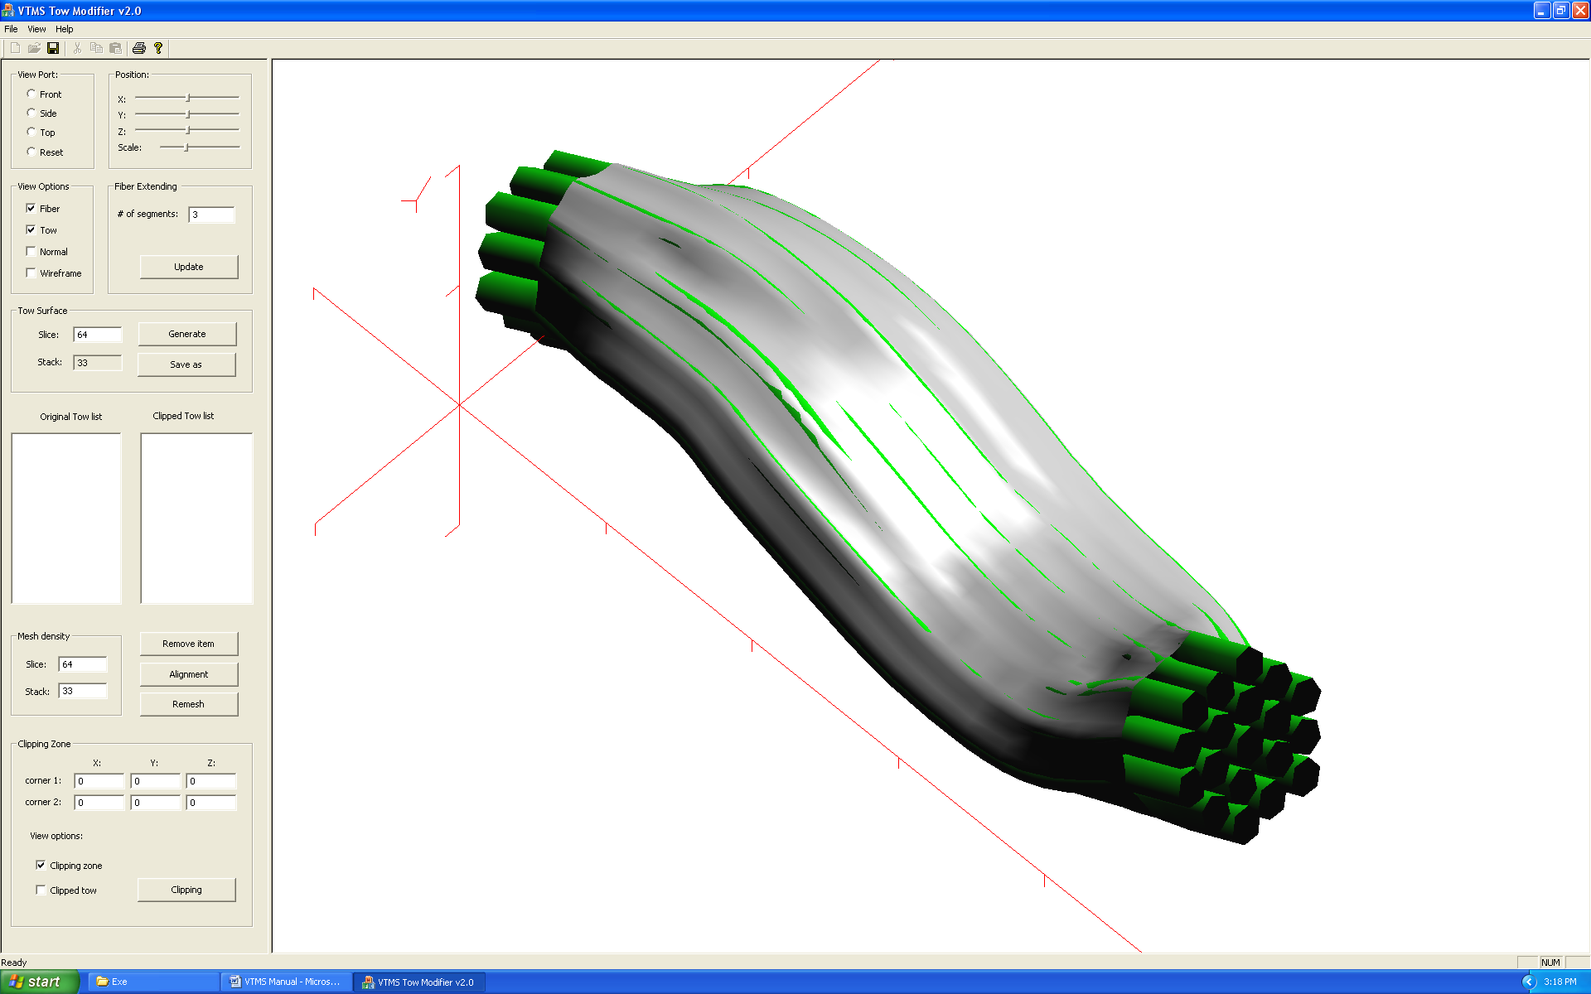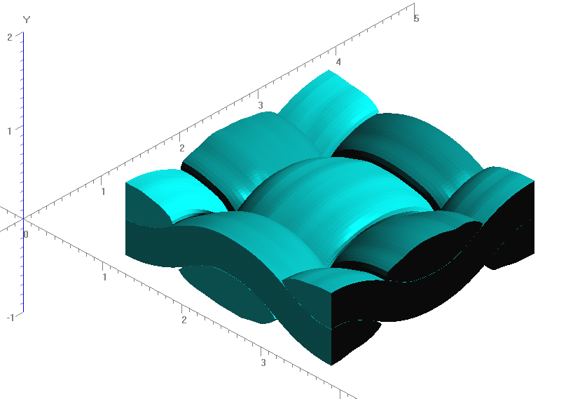

**Figure 1: Evolution of Weave Tow Geometry**

**Figure 2: Rough Sketch of Penetration Phenomena**

* Show penetration Figure 2 for reference of penetration case
* Show comparison of VTMS to NURBS representation of test case in Figure 3 for comparison
* Show Figure 4 to introduce penetration curves

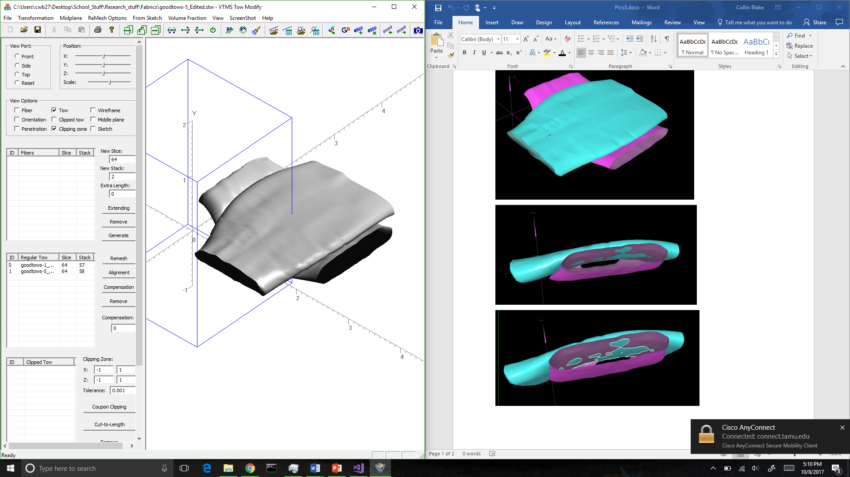

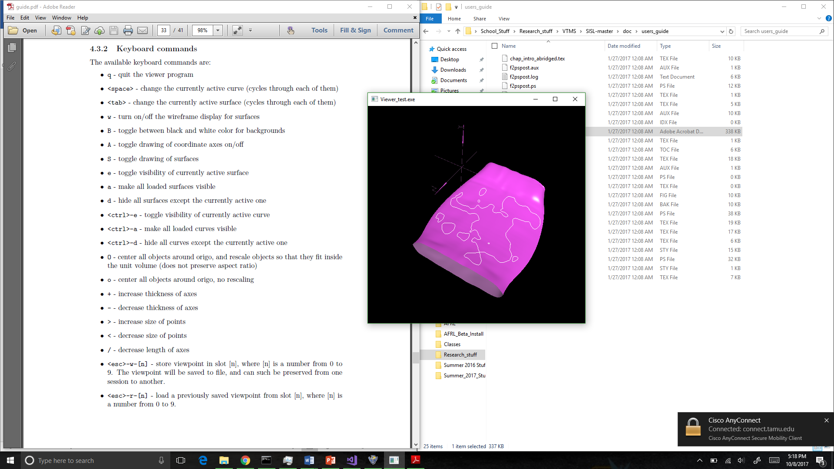

**Figure 4:Surface with Penetrating Regions Outlined in White**

**Figure 3: VTMS Surface (Left) and a NURBS Representation (Left) of the Same Surfaces**

* Discuss need for different visualization in ParaView for more refined viewing control. No figure needed
  + Refined visualization allows using identification numbers for nodes, elements, etc.
  + Allows us to focus and better identify key features of the problem
* Discuss method for creating individual “meshes” for curves via connecting nodes with two node elements
  + Library returns points for penetration curve that can be connected with linear two-node elements to create a “curve” mesh
  + Allows quick identification of curves and other mesh manipulation algorithms to be applied
* 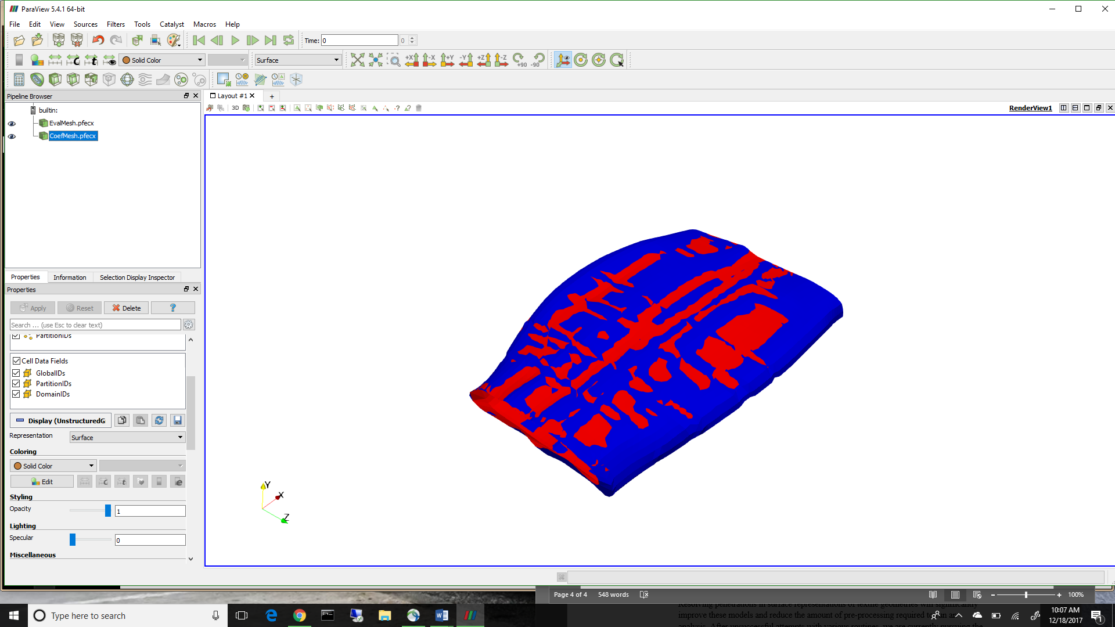Discuss control point vs. surface evaluation representation and why each is important. Possible figure
  + Control points are original data passed from VTMS
  + Surface evaluation gives surface location at parameter value
  + the results are not identical, however there are not large differences between the two
  + Red is evaluated, blue is control points mesh
* 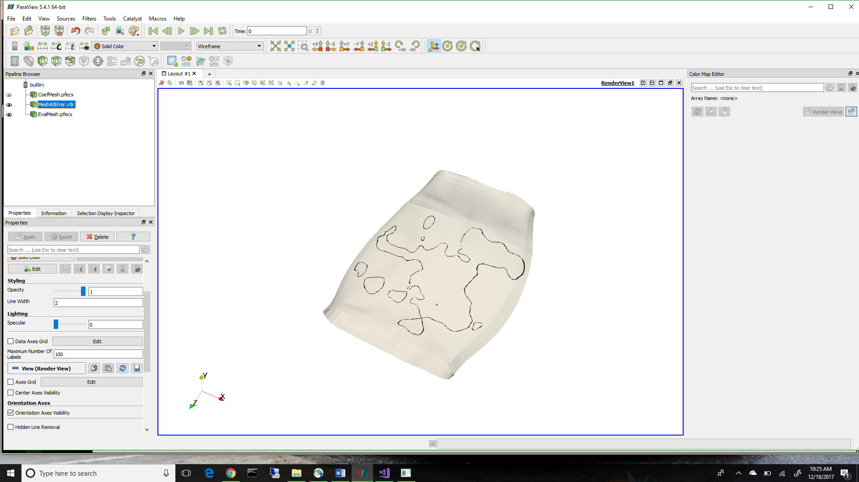Show Penetration curves and surface in ParaView to show updated visualization capabilities
  + Mainly to show capabilites

1. **CONCLUSIONS/ANALYSIS TO DATE**

* Now have method to better view geometries and have mesh representations of intersection curves and surfaces
* Need to fix unconnected/open curve situations

1. **WORK FORECAST AND PLANS**
   * Work on fixing open curves.